

**BA 385T – Financial Management – Accounting Portion – Fall 2023**

**Instructor – Brian Lendecky (**[**Brian.Lendecky@mccombs.utexas.edu**](mailto:Brian.Lendecky@mccombs.utexas.edu)**)**

**copyright © 2023 Brian Lendecky (DISTRIBUTION IN ANY FORM IS PROHIBITED)**

**Class #12 and #13 – Monday October 2 and Wednesday October 4**

**Topic #5 – Performance Evaluation: The Balanced Scorecard**

**Article – “The Balanced Scorecard: Measures That Drive Performance”**

**Case – None**

**This packet of class notes is copyrighted and created for the exclusive use in classes at The McCombs School of Business.** Any copying or distribution of this packet (electronically or hard copy) is a violation of federal law and will result in disciplinary actions being taken against the student.  Additionally, the sharing, uploading, downloading, and/or distribution of this packet (including, but not limited to, Slack, Chegg, Course Hero, social media sites, etc.) is a violation of the University's Student Honor Code and an act of academic dishonesty, which will result in further disciplinary action. This above also applies to McCombs students who download this material *from* Chegg, Course Hero, Slack, social media sites, etc. The following quote is from Chegg (Course Hero & other sites have similar policies): *“If you have concerns that students may be using our products inappropriately, Chegg is here to work with you and address your concerns. We will cooperate with any investigation by an academic instruction.”* I frequent Chegg, Course Hero, and other similar sites. I will and have contacted these sites in the past and they have been cooperative in providing me the name of students who downloaded and/or uploaded my material, which I then used to file McCombs academic dishonesty grievances. IT’S NOT WORTH IT! ALL acts of academic dishonesty receive significant penalties and are reported to Student Judicial Services and attach to your record.

**Balanced Scorecard**

What’s wrong with evaluating managers strictly from financial measures (ex. Net Income, Return on Investment, Residual Income, Economic Value Added, Budgets, Variance Analysis)?

Strictly short-term

It’s a lagging indicator – measurement of past results. Not necessarily indicative of future results.

The Balanced Scorecard is a popular management control system used to evaluate employees because it considers short-term and long-term factors (using both quantitative and qualitative criteria). The Balanced Scorecard translates an organization’s strategy into a set of performance measures that provides the framework for implementing that strategy. ***“What gets measured is what gets done.”***

Using a Balanced Scorecard employees are evaluated on four perspectives, each building on the next. Each of these four perspectives are measured using critical success factors (CSFs), (which are also known as key performance indicators, KPIs) that are consistent with the company’s strategy.

The four perspectives of the Balanced Scorecard are:

1. Financial – evaluates the profitability of the strategy and the creation of shareholder value

How do our shareholders see us? How profitable are we?

CSFs – net income, ROI, RI, EVA, Earnings Per Share, Profit Margin, budgets, variance analysis, etc.

2. Customer identifies target customers and market segments and measures the company’s success in these segments.

How do customers see us? Are we taking care of current and future customers?

CSFs – number of new customers, number of repeat customers, percentage of market share, customer complaints, customer satisfaction via surveys.

3. Internal business process - Identifies and measures the internal operations that create value for the customers.

What must we excel at to create value for our customers?

It is possible for a company to be financially successful and have satisfied customers, but still be at a significant risk of failure. How is that possible? This most often happens when companies focus lots of attention on the things that are making them successful now but not enough attention on the bigger picture of the competitive environment they operate in, failing to adapt to changes in consumer tastes, technology, etc.

CSFs – number of defects, machine downtime, finished goods per day per employee, cycle times

4. Innovation & Learning/ Growth – identifies and measures the people and system capabilities that support operations.

Are we developing our employees? Are our employees continually growing and creating value( aka valuing towards promotion) ?

This perspective of the balanced scorecard is the section where an organization measures its transformation skills and the strengths of its core resources. These are measures of company health, of the critical attributes that allow an organization to learn and grow.

CSFs – employee turnover rates, training hours, employee satisfaction survey results

**For the Balanced Scorecard….one size does NOT fit all!!**

*Never lose sight of the key point. For companies the primary goal of the balanced scorecard is to sustain long-run financial performance. Nonfinancial measures simply serve as leading indicators for the hard-to-measure long-run financial performance.*

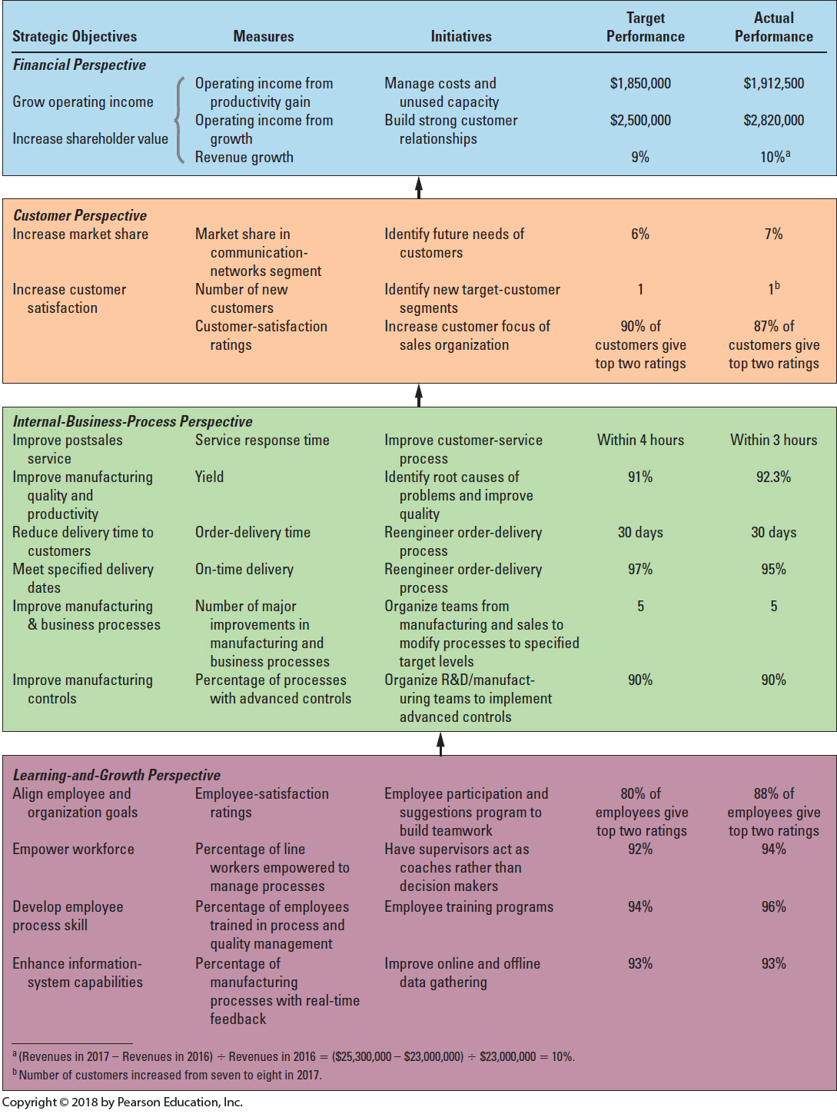

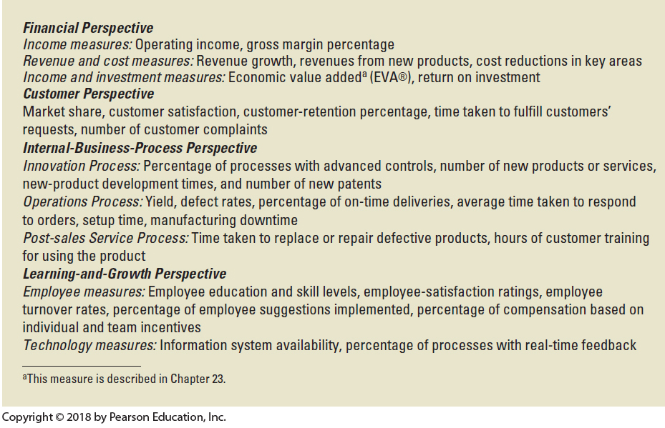

The below was an e-mail exchange that included, among other professors, Bill Kinney one of our most award winning researchers and Dave Platt the undergraduate dean.

The larger topic we were discussing were some of Southwest Airlines successful business practices. I took an excerpt of the conversation that relates to our current topic.

**From:** David Platt  
**Sent:** Tuesday, February 14, 2012 12:01 PM  
**To:** William Kinney; Jaime Schmidt  
**Cc:** Michael Williamson; Brian Lendecky  
**Subject:** RE:

Thanks Bill.  Ties in perfectly with our discussion of Balanced Scorecards.

Dave

**From:** William Kinney   
**Sent:** Tuesday, February 14, 2012 11:57 AM  
**To:** David Platt; Jaime Schmidt  
**Cc:** Michael Williamson; Brian Lendecky  
**Subject:** RE:

At a McCombs presentation about 5 years ago chaired by a Business Week reporter, Herb was asked whether “He worried about keeping stockholders happy.”

He said something like “I don’t worry about the stockholders; I worry about ‘my people.’  If employees are happy, then they’ll work hard and customers will be happy, and if customers are happy they’ll buy tickets and that will raise profits and stockholders will be happy.”

THEN, someone (I think, me) then asked whether Southwest MEASURED Employee Satisfaction.  He said “YES, of course.”

Great story, huh?

Bill

---------------------------------------------------------------------------------------------------------------------------------------

Ric Campo, Chairman of the Board & CEO of Camden Property Trust (NYSE:CPT):

“Many companies are all about making a profit and producing total shareholder returns that are superior to others.  I subscribe to a different way of thinking.  Camden exists as a company to improve the lives of our teammates, our customers, and our shareholders, one experience at a time…We aim to put smiles on the faces of our employees, which puts smiles on the faces of our customers, which puts smiles on the faces of our shareholders.”

**From:** Miguel Angel  
**Sent:** Wednesday, November 18, 2015 5:03 PM  
**To:** Brian Lendecky  
**Subject:** Balanced Scorecard

Hello Brian,

Here is the note on Club America receiving the Balanced Scorecard induction to the Hall of Fame as well as our picture with Professors Kaplan & Norton.

Regards

<http://www.clubamerica.com.mx/club-america-recibe-reconocimiento>

Balanced Scorecard Hall of Fame for Executing Strategy – 2015

- Anhui Xinhua Media Co (Wanxin Media) – a state-owned enterprise operating primarily in the Anhui province of China

- Bursagaz – a Turkish natural gas distributor

- CHRISTUS Health – a US-based healthcare provider

- Club America – a Mexican football team and the first professional sports organization inducted

- DeFacto – a clothing retailer in Europe and the Middle East

- Renault Australia – auto manufacturer

- Janalakshmi Financial Services – provides banking, loans, and other financial products to underserved urban customers in India

- PlayCity Casino – a casino in Mexico

- City Government of San Fernando, La Union – the capital of La Union province in the Philippines

- Portuguese Navy

[](http://www.clubamerica.com.mx/club-america-recibe-reconocimiento)On the field at Azteca Stadium - Club America vs Pumas (9/24/16) and vs Veracruz 2017.

 

How about an update on United’s Balanced Scorecard…

**From:** The Wall Street Journal   
**Sent:** Friday, April 21, 2017 4:55 PM  
**To:** Lendecky, Brian  
**Subject:** WSJ News Alert: United Says CEO Munoz Won’t Take Chairmanship

**United Says CEO Munoz Won’t Take Chairmanship**

United Continental moved to further stem fallout from the incident in which police dragged off a paying passenger from one of its flights, saying its chief executive Oscar Munoz will no longer be taking on the chairman role and that it will revamp executive-compensation incentives.

In a federal filing on Friday, United said its board is planning to adjust managerial incentive compensation to focus more on performance measures related to customer service.

I found this in United’s 10-K for the year ended December 31, 2017:

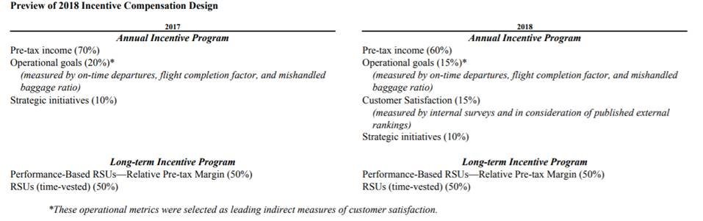

How about another United Airlines update?

When I first saw the below article I thought it was from The Onion or a similar satire site. But nope, it was real and in the Chicago Business Journal. Not surprisingly, United rolled this back quickly.

**United Airlines employees shocked: Bonuses replaced with lottery**

By Lewis Lazare  –  Chicago Business Journal

Mar 2, 2018, 4:47pm CST

United Airlines President Scott Kirby sent shock waves through the employee ranks at the Chicago-based airline today. Kirby issued an employee memo in which he announced that the Chicago-based airline is dropping the quarterly performance bonuses the carrier had been giving out to all employees qualified to receive them.

Kirby said in the memo, obtained by the Chicago Business Journal, that the bonus payouts are being replaced with a new program called "core4 Score Rewards," which Kirby said would include quarterly prizes like cash ranging from $2,000 to $40,000, luxury cars, vacation packages, and a grand of prize of $100,000 awarded to one eligible employee per quarter.

Kirby went on to say that each quarter that United reaches at least one of the performance goals outlined in the memo, there will be a drawing for the prizes listed in the memo. Of course, only the winners of this lottery drawing would get the prizes, apparently leaving the rest of eligible employees with nothing to show for their contributions in helping United achieve its performance goals.

Oddly, Kirby connected the bonus decision to the core4 program Kirby began rolling out in January of this year. "As we look to continue improving, we took a step back and decided to replace the quarterly operational bonus and perfect attendance programs with an exciting new rewards program called 'core4 Score Rewards'," Kirby wrote. The core4 program Kirby referenced is designed to make employees at United a more caring lot as they carry out their daily duties at the airline.  The hope Kirby expressed earlier this year is that United will build an overall image as a more caring airline as the core4 program gets into full swing across the United network.

But sources among United's rank and file employees late today said Kirby's memo has quickly ignited a firestorm within the employee ranks at the airline, which may not help create that caring attitude Kirby is seeking. A United spokeswoman had this to say late today about the changes: "We announced a new internal program based on United meeting certain operational and dependability metrics as a way of offering meaningful rewards to our employees. We believe that this new program will build excitement and a sense of accomplishment as we continue to set all-time operational records that result in an experience that our customers value."

Excitement may not be what many United employees' first reaction will be to Kirby's news today. But one thing is certain. Kirby can ill-afford to jeopardize the improving on-time performance metrics United has seen over the past year. As Kirby also noted in today's memo about the new lottery: "I couldn't be more proud of our performance in 2017. We set all-time records in almost every operating metric, and on the metric that probably best represents our core operating performance, D:00, we were number one in the industry." "D:00" is the metric for flight departures that occur at or before a flight's scheduled departure time.

An example of one of my prior performance reviews (how my raise and/or bonus was determined):

45% - Corporate achieves budget

55% - Austin facility

10% - Accounting department achieves budget

10% - improve a process

10% - “support management team”

10% - learn something new (cross-train)

10% - formal training

5% - no accidents

Key Do’s for the Balanced Scorecard

1. Think small and big

2. Goldilocks – Have the right number of measures.

3. Make sure your scorecard aligns with your strategy

4. Be willing to tweak your scorecard (realize trade-offs might have to be made)

“What gets measured is what gets done.” You don’t believe me?

**From** [**www.foxsports.com**](http://www.foxsports.com) **on April 13, 2017:**

**Blazers F Mo Harkless made $500K by not shooting 3-pointers in the season’s final week**

**By Cameron DaSilva**



Portland Trail Blazers forward Maurice Harkless attempted 194 3-pointers this season – the most in his career. That number likely would have been much higher if not for a contract bonus that hung over his head for the last few games of the season.

As Bobby Marks of The Vertical pointed out on Wednesday ahead of the Blazers’ last game, Harkless would receive a $500,000 bonus if he finished the season shooting above 35 percent from 3-point range. He entered the season finale at 35.1 percent, so one miss would have sent him below the 35-percent mark.

Not surprisingly, Harkless didn’t attempt a single 3-pointer in the season finale and shot only one in his last four games of the season. He had just six games all year where he didn’t attempt a 3-pointer, and three of them came in the final three games of the season. In other words, in the first 79 games of the season he did not shoot a 3-pointer in 3.8% of the games. In the last 3 games of the season he did not shoot a 3-pointer in 100% of the games.

Harkless absolutely knew what he was doing, and no one would blame him for it. He even joked about it on Instagram after Wednesday night’s game.

Add that $500,000 to his $8.9 million base salary and Harkless was paid fairly well this past season. His bonus secured, look for him to start taking a few more shots from long distance when the Blazers begin their playoff series against the Warriors this weekend.

**Todd Gurley 'mad as hell' about scoring late TD, giving Lions time to win game**

October 26, 2020 12:25 pm Notice Date!

Todd Gurley might’ve had the first touchdown he has ever regretted scoring this past Sunday against the Detroit Lions. With 1:04 left in the game, Detroit out of timeouts and the Atlanta Falcons down 16-14 to the Lions, Gurley ran a touchdown in on first-and-goal.

Obviously, the Falcons needed to score to win, but they also left too much time on the clock, allowing the Lions to mount a 75-yard drive capped by a touchdown as time expired. Gurley tried to stop himself from going in but his momentum carried him into the end zone accidentally.

“I was mad as hell,” said Gurley on the touchdown. “I was trying not to (score). My momentum took me in.” This was a mental mistake from Gurley that he was very unhappy about.  Atlanta could have easily killed the remaining time on the clock and kicked an easy game-winning field goal as time expired to win by one point.

“We talked about it in the huddle, probably a couple plays prior to that,” Gurley said. “And I know that, like I said, I’ve been in multiple situations over my years in the league. Just one of those unfortunate ones.” Even though Atlanta’s defense let up a 75-yard drive for a touchdown in just one minute, Gurley owned up for his mistake and took all the blame for the loss. “I’ll man up, take the responsibility. Tried to go down but I didn’t,” said Gurley. “Trying is not good enough, so just got to do better on my behalf.”

**From:** xx   
**Sent:** Thursday, October 29, 2020 9:39 AM  
**Subject:** Performance Management and Control

Hi Brian,

I took your class last semester and really enjoyed it. Knowing you’re a sports fan I’m assuming you saw Todd Gurley’s failed attempt to stay out of the end zone. You think this might have had something to do with it…

**Todd Gurley agrees to contract with Falcons after being cut by Rams**

April 6, 2020 Notice Date!

Seventeen days after Todd Gurley reportedly agreed to a contract to join the Atlanta Falcons, the team made it official. The Falcons announced Monday that Gurley agreed to terms on a contract.

Gurley’s $5,500,000 fully guaranteed contract also includes $500,000 in incentives. Gurley receives the full $500,000 if he reaches 13 touchdowns or 1,000 rushing yards. The Los Angeles Rams still owe him another $5.05 million, the portion of a guaranteed roster bonus not covered by offsets.

The Rams made Gurley, the 2017 NFL Offensive Player of the Year, the highest-paid running back in NFL history before the 2018 season -- awarding him a four-year, $60 million extension that included $45 million in guarantees. It had grown increasingly apparent by the end of last season, however, that the relationship between the Rams and Gurley had soured. Gurley's usage last season was down from 2018, when he rushed for 1,251 yards and scored a league-high 21 touchdowns. Gurley rushed for a career-low 857 yards last season and questions about the health of his left knee persist.

**From:** xx   
**To:** Lendecky, Brian  
**Subject:** Re: Balanced Scorecard - United Airlines

Professor Lendecky,

I was in your Houston MBA Managerial Accounting class. I've since moved out of Finance and back to my old world of environmental sustainability, and listened to your webinar today--thank you for it! I wanted to email about a few topics you raised and share my experience.

**Mo Harkless Example and Sustainability**

I encounter this phenomenon regularly when it comes to sustainability, but in a different form. When I work with lower-level employees, they aren't willing to spend time/money on long-term sustainability issues because it hurts their tightly defined goals. What gets measured is what gets done and the lower-level employees aren’t measured on sustainability. The higher up we go in the chain, the more success we have in achieving buy-in. The few times we go to the C-suite, we get what we want every time--but it doesn't necessarily translate to lower levels following that lead.

**Example: American Airlines Early 2000's**

One prominent example of short-term financial metrics from my former industry and Texas is American Airlines in the early 2000's--executive bonuses were tied to stock price vs. peers. Post-9/11, the industry was going into bankruptcy, so everyone's stock was tanking. American was trying to restructure outside of bankruptcy, so their stock price didn't fall as much, and executives received big bonuses for saving the company (for the time being). But this coincided with union employees taking major concessions, and the optics were so bad that [unions refused concessions unless CEO Don Carty resigned](https://www.chron.com/business/article/American-Airlines-CEO-Donald-Carty-resigns-2118332.php). American eventually went into bankruptcy in 2011, four years after all its last competitor had exited--a lost decade.

----------------------------------------------------------------------------------------------------------------------------

From: xx

To: Lendecky, Brian <Brian.Lendecky@mccombs.utexas.edu>

Subject: Balanced Scorecard: PG&E executive compensation

Hi Brian,

Thought you’d be interested to see what Pacific Gas & Electric, the investor-owned utility serving Northern California, is doing (well, forced to do by state regulators) on executive compensation.

I covered this company as a journalist prior to McCombs. PG&E was forced to declare bankruptcy in 2019 and plead guilty to felony manslaughter charges in 2020 because of lax internal controls, including allowing literally 100-year-old power lines to “run to failure.” The company’s infrastructure has sparked wildfires that have killed more than a hundred people, destroyed tens of thousands of homes, and burned hundreds of thousands of acres of land over the past decade. This wasn’t even PG&E’s first criminal stint: in 2016, the company was convicted of obstructing a federal investigation into a 2010 pipeline explosion that killed eight people.

In recent years, there was public outcry that PG&E funneled ratepayer funds to buybacks and bonuses rather than infrastructure upgrades.

A new state agency was created in response that realigned utilities’ executive compensation from activity/effort-based metrics (“we tried to do better, even though we literally killed people this past wildfire season”) to outcome-based metrics (ex. decreases in wildfire ignitions and downed wires).

Here is the short-term incentive program scorecard:

And here is the long-term incentives program scorecard:

Investors have obviously soured on PG&E stock. It’s down more than 63% over the past five years and has stayed low ever since, with the first drop below due to the PG&E-sparked 2018 Camp Fire that killed 85 people and destroyed 18,800-plus homes — making it the deadliest and most destructive wildfire in California history.

It’s a vicious cycle, though. Investor-owned utilities are natural monopolies whose returns on equity are set by state regulators. Utilities can’t invest in expensive infrastructure upgrades without shareholder investments. And if shareholders think that utilities aren’t worth investing in because they’re sparking wildfires and thus incurring regulatory wrath and criminal charges, then the infrastructure won’t be upgraded and thus safe enough to prevent those wildfires in the first place.

Hopefully this (mandated) shift from activity/effort-based metrics to outcome-based ones will properly motivate executives and help put this felonious company (literally) on the right track.

Best,

xx

**From:** xx  
**To:** Lendecky, Brian <Brian.Lendecky@mccombs.utexas.edu>  
**Subject:** Following Up

Hi Brian,

I hope your summer is going well! I had to send a quick email. I started my internship at JPMorgan Chase this week and was in New York for a week where we heard from leadership all across the bank. At one point, one senior leader said, “What gets measured is what gets done,” and I immediately thought of your class. Great to see it applied so quickly in my internship!

Best,

xx

----------------------------------------------------------------------------------------------------------------------------

**From:** xx   
**To:** Lendecky, Brian <Brian.Lendecky@mccombs.utexas.edu>  
**Subject:** What gets measured is what gets done

Hi Brian,

I just wanted to share that today, our Marketing Fellows class presented to Tony Rogers, Chief Member Officer at Sam's Club, and members of his team. He emphasized that what gets measured is what gets done, and it was a great way to reinforce what we learned in your class. Just wanted to share this anecdote with you!

----------------------------------------------------------------------------------------------------------------------------

**From:** xx   
**To:** Lendecky, Brian  
**Subject:** What gets measured is what gets done :)

I hear it ALL. OF. THE.TIME. Always makes me think of you – hope you and your family are doing well!

Take care,

xx

(Class of 2019)

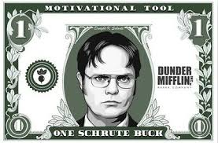

**More Balanced Scorecard Takeaways**

1. According to a 2015 *Harvard Business Review* article, nearly all employees **want** feedback on how to improve performance, but most leaders **avoid** giving either positive or corrective feedback. This paradox happens because most leaders find the process uncomfortable, and many are never trained in this valuable skill.

2. The primary purpose of a Balanced Scorecard (or Performance Scorecard) is to communicate a particular strategy down the organization and establish a basis for evaluation based on this strategy.

3. Linking employee pay to nonfinancial performance measures offers potential benefits:

- Because nonfinancial measures are leading indicators of future financial performance, they can serve as good diagnostic tools. Managers can get a glimpse of a business’ progress before a financial verdict is pronounced. “Get ahead of a problem”.

- Employees can receive better information on the specific actions to achieve strategic objectives. Nonfinancial performance measures helps communicate strategy to employees and motivates specific actions they can take to further this strategy.

In creating the Balanced Scorecard there is a shift of decision rights from lower-level managers to top managers. When the only performance indicators were financial measures, lower-level managers could achieve financial performance in several different ways. However, when performance includes financial as well as non-financial measures, lower-level managers have less alternatives to achieve financial performance because they have to perform in certain dimensions as specified by top managers.

4. Survey evidence (“Coming Up Short on Nonfinancial Performance Measurement”, Ittner and Larcker, Harvard Business Review) suggests that many organizations do not realize the above benefits because of the following common pitfall:

- Organizations fail to link nonfinancial performance measures to strategy. Less than half of companies utilizing balanced scorecards developed cause-and-effect statistical models demonstrating how increasing nonfinancial performance measures would result in higher future financial performance.

One company that did NOT fall into this common pitfall was an early adopter of the Balanced Scorecard, Sears. Back in the 1990s Sears statistically demonstrated that a:

5 unit increase in their employee attitude KPIs led to a

1.3 unit increase in their customer impression KPIs led to a

0.5% increase in revenue growth

I fully realize referencing Sears today as an example might be a bad idea. But, Sears pioneered the mass shopping model in the late 1800s, about 100 years before Amazon would perfect the model for online commerce and ultimately lead to Sears’s downfall. Sears management has been unable to formulate a response to the shift toward online commerce, and Sears filed for Chapter 11 bankruptcy protection in 2018.

5. Many companies like to use subjective measures to evaluate certain criteria of the Balanced Scorecard, particularly the Customer and Innovation/Learning/Growth criteria. One downside to using subjective measures is inconsistency. Research has shown managers may rate other people’s skills inconsistently, but they are highly consistent when rating their own feelings and intentions (Mount, Scullen, and Goff, 2000, *Journal of Applied Psychology*; and M. London, *How People Evaluate Others in Organizations*).

One organization that feels they have solved this rater inconsistency problem is Deloitte. From “Reinventing Performance Management” by M. Buckingham and A. Goodall, *Harvard Business Review* (April 2015):

“This gave us pause. We wanted to understand performance at the individual level, and we knew that the person in the best position to judge it was the immediate team leader. But how could we capture a team leader’s view of performance without running afoul of what the researchers termed “idiosyncratic rater effects”? ...

…The solution requires a subtle shift in our approach...rather than asking people for their opinion of a team member (in a 360-degree or an upward-feedback survey, for example)...we found that we need to ask a different kind of question. People may rate other people’s skills inconsistently, but they are highly consistent when rating their own feelings and intentions. To see performance at the individual level, then, we will ask team leaders not about the *skills* of each team member but about their *own future actions* with respect to that person...we’ve refined the wording of these statements through successive tests, and we know that at Deloitte they clearly highlight differences among individuals and reliably measure performance…

A. Given what I know of this person’s performance, and if it were my money, I would award this person the highest possible compensation increase and bonus [*measures overall performance and unique value to the organization on a five-point scale from “strongly agree” to “strongly disagree”*].

B. Given what I know of this person’s performance, I would always want him or her on my team [*measures ability to work well with others on the same five-point scale*].

In effect, we are asking our team leaders what they would *do* with each team member rather than what they *think* of that individual.”

During our class discussion, the topic of compensation information being confidential usually comes up. If it did:

New York Post

Millennials are more likely to tell you how much they make

By Jacob Passy, Marketwatch 10/18/17

Traditionally when it comes to discussing salaries in the workplace, mum’s the word. But millennials appear to be throwing that practice by the wayside along with dinner dates and shopping at department stores.

Nearly one in three workers between the ages of 18 and 36 (30 percent) said they talk to co-workers about how much money they make, according to a new study released by personal-finance website The Cashlorette.com, a subsidiary of Bankrate. And older millennials (those ages 27 to 36) are slightly more likely to make this bold move, at 33 percent.

Social media and peer-to-peer payments apps like Venmo could be making young people more comfortable talking about finances in general, said Sarah Berger, founder of The Cashlorette.com. Millennials have also tapped into the push toward closing the wage gap between men and women and among people of different racial and ethnic backgrounds, she said. “Millennials might feel emboldened to talk about money at work to make sure they’re at a company that’s making an effort to close the wage gap,” Berger said.

Baby boomers prefer to keep financial matters between friends and family

- Seventy-one percent baby boomers will discuss salaries with their spouse or significant other, a larger share than any other generation. Just 64 percent of Americans overall will talk about their wages with a spouse.

- One in five Americans will talk salary with coworkers. Meanwhile, just 8 percent of baby boomers will share this information with colleagues.

*Note from Brian Lendecky – the remainder of this article is not the focus of our case discussion. I am not agreeing or disagreeing with the rest of the article, but just including it out of fairness to the author.*

Why people should talk about salaries

Pay transparency is frequently touted as a means of addressing wage inequality. While no study has identified a direct link between secrecy around salaries and the wage gap, a 2014 study from the Institute for Women’s Policy Research found that “secrecy appears to contribute to the gender gap in earnings.” In particular, nearly two in three single mothers said their employer discouraged or prohibited discussion about salaries, compared with 51 percent of women and 47 percent of men overall. Talking about salaries more might not just address disparities in pay, others have argued morale and collaboration among coworkers improves when they know they are on a level footing earnings-wise.

People’s concerns of retribution are not supported by law

Rather than mere etiquette, fear of retaliation by management and getting fired for discussing salaries is what keeps more people from doing so, millennials and baby boomers alike. And much of that fear stems from the employers themselves. “There are a shocking number of employers who threaten or cajole employees into not discussing their pay,” said Donna Ballman, an employment lawyer based in Fort Lauderdale, Fla. “Any discussion of wages is going to raise your boss’s hackles.”

The National Labor Relations Act protects most workers’ rights to talk about pay with co-workers. But Ballman cautions that anyone considering doing so first check to make sure they are not exempt — the law generally does not cover government employees, agricultural laborers, independent contractors and supervisors.

If a boss threatens an employee for talking about their salaries, Ballman recommended going to human resources and pointing to the guidelines put forth by the National Labor Relations Board (NLRB). And if someone is fired or retaliated against for this, she said they should file a complaint with the NLRB or find a lawyer through the National Employment Lawyers Association. While discussions like these are important in closing the wage gap, Ballman did say it’s important that workers consider more than just the legality of doing so. “You have the right to do it,” she said. “But you’ve got to be careful because your coworkers could be offended, too.”